Software Development Life Cycle (SDLC)

Software development life cycle is a well-defined, structured sequence of stages in software engineering for the development of a software product. Procedures and methods of software development paradigms are utilised to define SDLC.

An iterative approach is used to develop this system. This is simply induced from the way data must flow from one point to the next. The system consists of multiple functions passing data from one point to the next. From this we can see that it is important to pass the correct data from one unit to the next after processing has occurred.

Each function is designed – inputs and outputs of the function considered, mathematical weaknesses are checked and logical errors removed.

This stage is followed by coding. The code is then tested with random inputs and noisy inputs. Lastly the function is then merged to its family of functions for overall output evaluation. This process is iterated for all functions included in the system.

Project management

To keep track of changes in each component, we use git. Git is enabled in visual studio code where all the coding will be done. We use git to create four branches from the master branch. We use the old branching methodology, where all branches are created directly from the master branch and merged once a unit is completed.

Git branches:

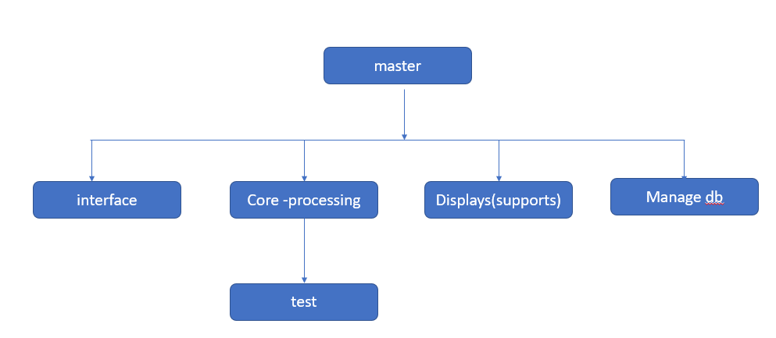

Time allocations for unit design, coding , testing and evaluation.

